Practical-13

Practical 13: Excel Student Result Management

Aim

To analyze student marks using Excel tools.

Objectives
• To apply Excel formulas
• To create charts

Materials Required
• MS Excel

Procedure

1. Enter student data – Input students’ names, marks, and other required details into the spreadsheet.

2. Use Flash Fill – Apply Flash Fill to automatically complete patterns such as separating names or formatting data.

3. Replace incorrect values – Identify errors and use Find & Replace or manual correction to fix inaccurate entries.

4. Calculate pass/fail using IF – Create an IF formula to determine whether each student passes or fails based on their score.

5. Use COUNTIF and AVERAGE – Apply COUNTIF to count specific results and AVERAGE to compute the class’s mean score.

6. Create charts – Generate visual charts to represent student performance trends or score distributions.

7. Apply conditional formatting – Use color-based formatting to highlight important values, such as low scores or top performers.
Students
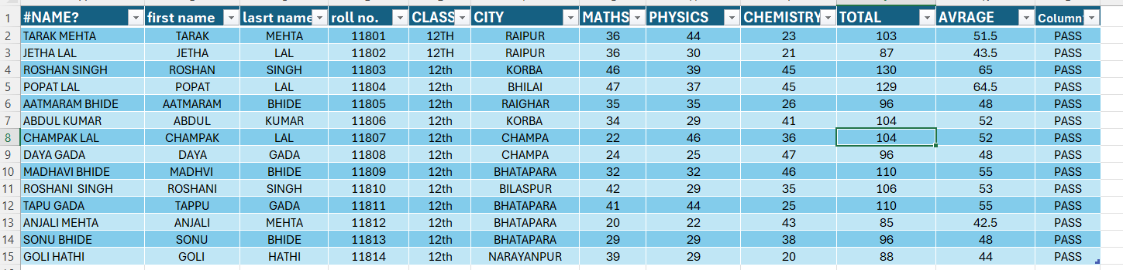
Mark
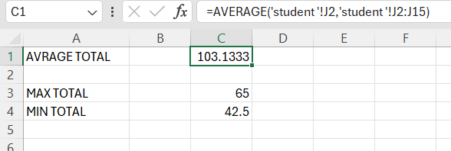

Chart
